Questions:

1. Do you have also the column names for the first files you sent, or does it follow exactly DATRAS format?
2. The “Distribution” file starts only from 1983.
3. Also, do you have the gear information I named before: Fishing line length, sweeps length and fishing speed.

Dear Colleagues,

I will try to answer to your questions:

* Data from our historical scientific surveys are prepared in DATRAS format.
* Old **scientific demersal trawl survey** data about cod and flounder from 1976 -1990 were converted in ICES DATRAS database exchange format. Prepared DATRAS exchange files quality was checked using screening tool available in ICES secretariat. It can be found in the website (<https://datras.ices.dk/Data%20submission/Default.aspx>). At this moment is not possible to check and upload data before 1991 into DATRAS database. For each survey prepared DATRAS exchange format file was converted in the way that allows checking data quality using screening tool. It is the reason why you can’t see the column names. This file is combination of 3 separate fails HH, HL and CA that are sorted as it was described in BITS manual. You can see the column names when you download already uploaded data from the DATRAS database, the same data but in other format, but with column names. In this format DATRAS database add some additional columns.
* For 1977 only the biological information has been prepared. It was not possible to prepare these data in ICES DATRAS database exchange format because part of necessary information is lost.
* For the pelagic trawls the maximal depth in meters for the investigated water is given. In DATRAS format it is not possible to give more than one depth.
* The distribution files of **commercial fishery** statistics starts from 1983. I would like to call this information “official landing information from Baltic” where information from different republics and organizations is combined together.
* Demersal /pelagic twin trawl  
    
  In two-boat or pair demersal/pelagic trawling (Figure 5) each vessel tows only one warp and by keeping a set distance between the vessels (0.2-0.3 nautical miles) providing the horizontal forces required to spread the gear, therefore the otterboards are not necessary. This means that two vessels of relatively modest engine power can tow a comparatively large trawl, increasing between 50% to 100% the volume of water swept per vessel. Shackled between warps (b) and bridles (d) a heavy wire sweep (c) ensures good bottom contact. In all other respects the net (a) is similar to a single boat trawl, with floats and heavy rockhopper groundrope providing the vertical forces around the net mouth. Warp length/water depth ratio is around 3:1 with activity confined mainly to the continental shelf (200m). Heavy sweep wire lengths can range from 100 to 400 metres, depending on bottom conditions and vessel capabilities. Towing speeds between 2.5-4.0 knots can be encountered, with around 2.8 knots the norm.

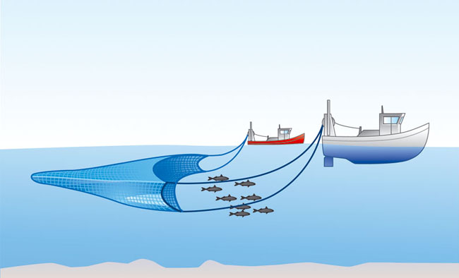

Demersal Pair Trawling Nets used for pair trawling are of similar design and netting material but tend to be much larger and heavier than comparable single-boat gears. As otter boards are not required to provide horizontal spreading forces vessels of relatively modest horsepower can tow a considerably larger gear between them. A rockhopper footrope (Fig. 7b) is frequently used to protect the net from bottom damage and the gear is usually shot and hauled over the stern using a net drum. A heavy length of wire and/or chain (200 m-400 m) is included in the rig between warp and bridles to ensure good bottom contact. After one vessel shoots its net the bridles are passed across to the partner with the aid of a messenger and connected to the heavy sweep wire. Both boats pay out wire as they steam ahead to take up towing positions (Fig. 13). Scottish pair trawlers generally tow between 0.15 and 0.25 nautical miles apart, taking into account water depth and bottom conditions. At the end of the haul both boats come together again and the previously transferred bridle is passed back to allow the first vessel to complete hauling operations.

Pelagic Pair Trawling (Mid-water Trawling) Mid-water or pelagic trawls are towed at the appropriate level in the water column to intercept shoaling fish such as herring or sprats. The location of the shoals is determined by sonar or vertical sounder echoes picked up by the vessels hunting in pairs. One boat then shoots its net and the partner vessel comes alongside to pick up upper and lower bridles. When both warps are shackled up appropriate lengths of wire are paid out and the vessels steam towards the target shoals (Fig. 15). The depth of net relative to the surface is indicated by an underwater instrument mounted on the net headline. Known as a net monitor or net sounder this instrument can be connected to the towing vessel by cable or can transmit acoustic signals to a receiver, either hull mounted or towed by one or both of the boats. Gear depth is controlled by changing the length of towing wires and/or altering towing speed. As with bottom pair trawls the absence of otter boards allows two vessels of modest horsepower to tow a relatively large trawl-net.